**Documentation BWINF 2021 Round 1 Task 1: Sliding Parking Lot**

Problem....................................................................................................................................2

Solving......................................................................................................................................4

Examples..................................................................................................................................5

Code.........................................................................................................................................6

**Problem**

There is a Parking Lot with cars in every slot and cars which are blocking in some positions the Parking Lot. One car has the length 2, so one car can block two cars. The code should get as input:

* In the first line the character of the first and the last car in the Parking Lot. For example: A, D => A, B, C, D
* In the second line the number *n*, which is the number of blocking cars in front
* In the following lines are first the character from a blocking car and his left position

For example:

1 A G

2 2

3 H 2

4 I 5

Line 1 -> cars in slot = {“*A*”, “*B*”, “*C*”, “*D*”, “*E*”, “*F*”, “*G*”}

Line 2 -> number of blocking cars *n* = 2

Line 3 -> blocking car one = H; positions: {2, 3}

Line 4 -> blocking car two = I; positions: {5, 6}

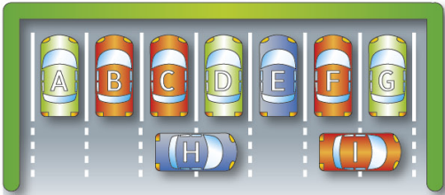

The code should give as output for every car in the slots, which blocking cars need to move how many steps and the direction, that the car can go out.

For example:

1 A: E 1 right

2 B: E 1 left

3 C:

4 D: